

Xolobeni Mineral Sands Project
Background
The Xolobeni Mineral Sands Project is a major heavy mineral sands deposit of an estimated 346 million tones at 5.0% heavy mineral (using 1% cut-off) located in Pondoland on the South African Wild Coast (see Tenement boundary in Figure 1). The mining lease area extends continuously along the coast for some 22km from the Mzamba River in the north to the Mtentu River on the southern boundary. The width of the lease area varies from 1.5km to 2km and covers an area of some 3300 ha. The heavy mineral sand deposits are contained within 5 blocks, each named after the river at its southern boundary - Mtentu, Sikombe, Kwanyana, Mnyameni and Mphalane – the seaward boundaries of which are located 50m inland of the frontal dunes (see Voluntary Exclusion Boundary in Figure 1).

Pre-feasibility work by the mining proponents demonstrates a 22 year life of mine for a US$200 million capital development including the construction of a mineral separation plant (MSP) and smelter. The nature of the deposit is ideally suited to a large scale conventional dry mining operation.

Figure 1. Location of the Xolobeni Mineral Sands Project
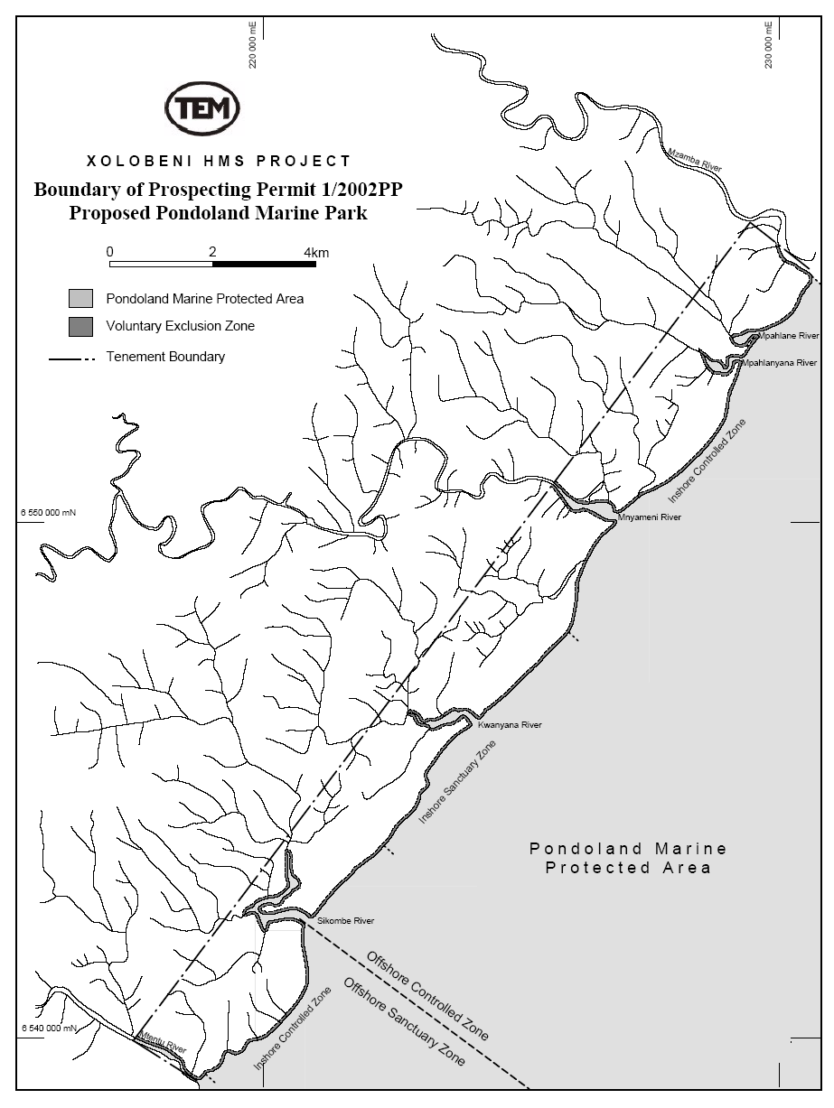
The affected land is owned by the State and held in Trust for the local people. The land is occupied by local communities as communal land, managed by both tribal authority and local government. The State has assumed nominal jurisdiction over the communal land until the Communal Land Rights Act (CLRA) is enacted.
Currently, under the Mineral and Petroleum Resources Development Act (2002), Mineral Commodities Ltd (MRC) subsidiary, TransWorld Energy and Mineral Resources (S.A.) Pty Ltd (TEM), has been granted an Unused Old Order Right by the Department of Mineral and energy Affairs and has until 30 April 2005 to apply for a Mining Right for Xolobeni.

The key mining role players
TransWorld Energy and Mineral Resources (S.A.) Pty Ltd (TEM), a company associated with Mark and Joseph Caruso, Directors of MRC, is a South African registered company and is the sole purpose holding company for the Xolobeni Mineral Sand Project.

Mineral Commodities Ltd (MRC) is an Australian-based resource company located in Perth and listed on the Australian Stock Exchange. The Board of MRC consists of Mark Caruso (Managing Director), Joseph Caruso (Chairman) and Greg Steemson (Executive Director). The Board and managements primary objective is to build wealth for its shareholders by actively identifying, assessing and participating in mining projects in Australia and overseas with established resources and the potential for substantial reserves which demonstrate a high probability of successful development and profitable production. Besides the Xolobeni Mineral Sands Project, MRC is also currently actively involved in assessing advanced stage mining projects in the Tormin Mineral Sands Project some 400km north of Cape Town on the West Coast, the Trekelano Copper Project in north-west Queensland, Australia and the Walvis Bay Mineral Sands Project in Namibia. At 31 December 2004, MRC held AUS$1 million in cash with a further AUS$4.4 million in marketable securities.

MRC entered into a Heads of Agreement with TEM to purchase a 49% interest in the Project. The interest was increased to 75% with the expenditure of AUS$1 million and a further increase of 5% will occur with the completion of a bankable feasibility study.

The main terms of the TEM agreement are:
- The Company will reimburse TEM AUS$400,000 for past exploration expenditure and will issue 5.5 million ordinary shares at 20 cents to TEM for a 49% interest in the Project;
- The Company will commit to spend AUS$1.0 m over 3 years to earn a further 26% interest in the Project;
- Once the Company has earned a 75% interest it will free carry TEM through to a decision to mine and in so doing earn a further 5% interest in the Project.
- TEM will have the right to convert its remaining interest in the Project into shares in the Company. If TEM exercises this right, its interest is to be valued by an independent expert. The value is to be acceptable to both parties and by the Company’s shareholders if required under the ASX listing rules at the time of the conversion.
- There is a 2% gross royalty payable to TEM on product sold from the Project.
The Xolobeni Empowerment Company (XolCo), a community-based BEE group, is represented by two black empowerment partners, Maxwell Bonqwana and Zamile Qunya. XolCo has an option to take a 15 percent stake in MRC local subsidiary, TEM, for US$10 million in 2 stages:
- an initial 5% interest in TEM for US$2.6 million, which may be exercised at any time until a bankable feasibility study is completed for the Xolobeni Project; and
- a subsequent 10% interest for US$8 million, which may only be exercised if the first stage has been completed.

A brief synopsis of the process to date
Pre-2001
- Prior to 2001, only 30% of the tenement area (see Figure 1) has been drilled. Based on a 1988-1992 report by Richards Bay Minerals (RBM) and work completed in 1996/1997 by Renison Goldfields, an Inferred Resource of 83 million tones of mineral sands grading 9.6% heavy minerals for 8 million tones of heavy mineral has been delineated for Xolobeni. Metallurgical testing by RBM has confirmed that the ilmenite is suitable for TiO² pigment production via the sulphate process or can be smelted to produce an enriched slag which is suitable for pigment production by either the sulfate or chlorination process
2001
- In May the MRC shareholders approved the acquisition of an interest in the Xolobeni Mineral Sands Project.
- MRC entered into a ‘Heads of Agreement’ with TEM to purchase a 49% interest in the project. The ‘Deed of Variation’ further provides for the right to earn a further 26% interest by spending AUS$1 million over 3 years. Also under the terms of the agreement, MRC may earn an additional 5% interest by undertaking a Bankable Feasibility Study (BFS) on the project (see terms of agreement above)
- The initial resource estimate for Xolobeni is given as 88 million tones grading 10% THM (5.5% VHM) and 12.7% slimes at 4% THM cutoff

2002
- Xolobeni Prospecting Permit (reference 1/2002 PP) is granted to TEM, valid until 13 July 2004 with an option to extend for a further 2 years. The renewal of the prospecting permit allows exploration to continue on the Xolobeni Sands Project and grants TEM the exclusive right to enter into a mining lease at any time during the term of the prospecting permit
- On 6 February 2002, TEM executed a Notarial Prospecting Contract which granted TEM the sole and exclusive option to convert its Prospecting Permit to a mineral lease. The Contract required the submission of a Business Plan, Mining Plan and Programme and an Environmental Management Plan.
- The resource drilling programme is completed. Some 25,469 metres were drilled, enabling a new resource to be announced comprising 313 million tonnes at 5.4% Heavy Mineral with an ilmenite grade of 2.9% based on a 1.5% HM cut-off. The resource was also upgraded to a combination of Measured, Indicated and Inferred classifications. Preliminary metallurgical testwork on a bulk sample demonstrated that standard mineral sand processes are able to efficiently separate the minerals. Metallurgical evaluation also confirmed that the ilmenite is suitable for TiO₂ pigment production via the sulfate or chlorination process. In addition to the deposit’s ability to host a stand alone mining project the deposit is geographically strategic as it is located within proximity of the largest TiO₂ slagging operations in the world.
- Final approval received for the investment by the South African Export Development Fund (SAEDF) in MRC Resources (Pty) Ltd for funding of US$1,500,000 for the Xolobeni Mineral Sands Project. The funding enables MRC to continue project development and the purchase of up to 20% of the shares in TEM.
- MoU signed with the East London Development Zone Corporation (ELDZC) securing a 10ha site for an ilmenite smelter within the East London Industrial Development Zone. The MoU was subsequently amended increasing the area under option to 30ha to allow for expansion of the smelting activities and the potential location of the mineral separation plant on the same site. The MoU provides for both parties to jointly undertake the pre-qualification study for the smelting facility.
- MRC and the engineering firm DEMAG AG sign a Heads of Agreement to conduct the component of the study relating to the smelter construction. This would be carried out at no cost to MRC, in return for a first right of refusal to undertake the full feasibility study of the smelter facility.
- The new Minerals and Petroleum Resources Development Act (MPRD Act) No. 28 of 2002 is promulgated (10 October, 2002)

2003
- SRK complete the Desktop Mining Study and confirm the value of the Xolobeni Project with an indicative pre-tax NPV of US$129 million. SRK Consulting was commissioned to prepare a resource estimate based on the 25,469 metre air core drilling program completed in 2002. The JORC compliant combination of Measured, Indicated and Inferred Resources using a 1.5% Heavy Mineral (HM) cut-off, has increased the tonnage of contained HM by 29% to 16.9 million tonnes and confirmed the deposit as one of the world’s key emerging mineral sands projects. The new estimate is 310 million tonnes at 5.4% HM with an ilmenite grade of 2.9%. This compares with the previously announced resource of 196 million tonnes at 6.7% HM and 3.0% ilmenite grade. Significant increases in tonnage were recorded in the Kwanyana and Mnyameni blocks. Details of the resource estimate are provided in the Table below. The study delineates the projects key resource blocks and completes a preliminary assessment of its risk profile and financial viability. The bulk of the resources are contained within the central Sikombe, Kwanyana and Mnyameni blocks.

Area | Resource  Status | Tonnes  (Mt) | %  HM | %  Fines | %  Ilm (2)
Sikombe | Measured | 77 | 5.9 | 18.0 | 3.3
Kwanyana | Measured | 125 | 6.3 | 19.6 | 3.3
Mnyameni | Indicated | 94 | 4.3 | 28.2 | 2.3
Mpahlane | Inferred | 14 | 2.7 | 28.3 | 1.9
TOTAL |  | 310 | 5.4 | 22.2 | 2.9

- BEE partner, Xolobeni Empowerment Company, is established for the Xolobeni Project (see terms of agreement above)
- Xolobeni Geological Report completed. The consultants’ geological report concluded that the Xolobeni prospect hosts a potential mineral resource exceeding 350 million tonnes containing between 2.5-3.5% ilmenite. The larger tonnage is expected to be achieved when an assessment of the southern (undrilled) Mtentu block is completed. Based on geological mapping, this block is known to contain mineral sand. The deposit is mineralogically complex due to the presence and influence of strand lines containing a high HM grade but within which are lower percentages of valuable minerals. Geological interpretation has identified such areas and individual analyses of the mineral suites are being undertaken. The characteristics of the various mineral suites will be assessed in the definitive feasibility study.
- The topographic and environmental review is completed.
- DEAT and DME completes the ‘cost-benefit analysis’ of mining including an analysis of the social, economic and environmental opportunities and constraints associated with heavy mineral mining but this analysis is classified ‘confidential’

2004
- Xolobeni mineral lease option exercised. The required documents (see above) were prepared and submitted to the Department of Minerals and Energy. In addition reports on Public Consultation, Social and Labour Plan Strategy, Environmental Review, Rehabilitation Procedures, and Market Analysis were also included. The submission fulfilled the requirements of the Contract and the Mineral Lease was signed and executed on 23rd April. The duration of the lease is 25 years. In terms of the Mineral and Petroleum Resources Development Act (2002), the lease will be classified as an ‘Unused Old Order Mining Right’ and TEM/MRC will have a period of twelve months to apply for a Mining Right as defined by the new legislation. The critical components of the application are a Scoping Study, Bankable Feasibility Study and Environmental Impact Assessment.
- Appointment of John Barnes as General Manager, Southern Africa. Mr Barnes was previously with Richards Bay Minerals where he held the position of Chief Exploration Geologist for 14 years.
- Groundwater Consulting Services appointed in November 2004 to undertake the Social and Environmental Studies required for the Mining Right Application (MRA). GCS sub-contract Tony Barbour and Vuyisile Zenani to undertake the Social and Labour Plan (SLP). IWR Source to Sea is subcontracted to GCS to undertake the hydrological survey work.
- Bateman South Africa engaged by MRC/TEM to provide process information and engineering support to the environmental consultants
- A South African transport company is contracted to prepare a proposal for the heavy mineral concentrate (HMC) and product transport options
- Eskom requested to submit a preliminary proposal to supply power to the project
- AMC Consultants (Australia) complete the Preliminary Mine Plan in preparation for the MRA
- I&AP meetings, facilitated by XolCo, held in November/December
- A water bore is drilled for safe drinking water and an adult basic education program initiated with ten teachers working part time in schools at Xolobeni

2005
- In consideration of a review of the limitations of the MPRD Act (particularly in respect of the time constraints for the completion and submission of the EIA), and as a result of a subsequent meeting with the Eastern Cape Department of Minerals and Energy Affairs, MRC/TEM decides not to submit a Mining Rights Application in early 2005. The collection of baseline data for the EIA will rather be undertaken under the umbrella of the Prospecting Right before the formal submission of an EIA as part of the Mining Right Application process. On 2 March 2005, TEM and GCS compile and submit a Prospecting Rights Application to the Eastern Cape Department of Minerals and Energy Affairs. The application is provisionally accepted subject to the compilation of a prospecting Environmental Management Plan (pEMP) by 1 May 2005. This pEMP is being drafted by TEM.
- GCS inform affected government departments of the amended approach to the formulation of the EIA

Some key points relating to the heavy minerals mining at Xolobeni
The Xolobeni project is very much akin to the other Southern Africa deposits. The Xolobeni Project Concept is as follows:
1. Dry mining: large scale earth moving equipment, backfill excavation with sand & tailings. The project has identified 5 blocks (see above). It is likely that mining efforts would concentrate on the three central blocks and potentially initially ignore the area north of Mtentu and south of Mzamba as grade/volumes are generally lower.
2. Wet Separation Plant (WSP): producing a heavy mineral (HM) concentrate. The WSP will be based on site.
3. Tailings dam: This will be required for disposal of fines. May need more than one if WSP is moved and new pits are opened.
4. Mineral Separation Plant (MSP): separates HM concentrate into constituents minerals. The MSP may be located on site or in EL.
5. Smelter & Fe Plant: Smelts ilmenite to produce slag & pig iron. The smelter will be located in EL (current planning) or on site.
6. Harbour load out facility: for loading of slag
7. Technically project is straight-forward but some issue will be very challenging.
  - Location & lack of infrastructure a problem
  - Market entry difficult
  - Scale: may be too small
  - Environmental resistance
  - “The major question is whether the project is economically viable given its location, market conditions & size?
8. Smelter & Fe Plant Single furnace will probably be located in EL. The smelter will be a major power consumer. This constitutes a major operating cost and area of greatest technical risk.
9. Transport Implications are that approximately 300,000 tpa need to be moved, using 48t road trucks this equates to 17 –18 loaded trucks per day. The haulage Distance to EL is 410km or to Coega 680 km. This is a significant cost factor. It is proposed to pipe the material to a haulage site.
10. Environmental Implications:
  - Water requirements – these will be high and there is no firm plan (at least that which is known) to address security of supply.
  - Tailings dams – significant impact and there is little mention of this in any available documentation.
  - Relocation of homesteads?
  - Road traffic to and from Xolobeni
  - Impact on estuaries?
  - Sense of Place?
11. Employment:
  - Probably generate between 200 (minimum) to 300 (at maximum) employment opportunities.
  - Backward and forward linkages are negligible and there will be virtually no economic impact
  - Induced (spin-off) employment multiplier probably 4.2. This equates to about 1000 t0 1500 additional employment opportunities.
  - Is tourism a more viable alternative?

The mining right application
It is the intention of TEM/MRC to prepare and lodge a Mining Right Application (MRA) with DME. The preparation and lodging of the Mining Right application is a 3 stage process.
- Stage 1 will involve lodging the formal application form, preparing a Scoping Report on the technical, financial, social and environmental aspects of the project, and submitting the Social and Labour Plan.
- Stage 2 will commence after notification from the DME that stage 1 has been accepted. At this stage work will start on a preliminary Environmental Impact Assessment (EIA) and a draft Environmental Management Plan (EMP).
- Stage 3 will commence after the DME has reviewed the preliminary EIA and draft EMP and Scoping Report. Stage 3 is comprised of pre-mine monitoring, the final EIA and EMP reports to be submitted to the DME for final approval.
The project is almost certain to go through a Bankable Feasibility Study (BFS). The BFS will have a host of components designed to demonstrate that the project is viable and hence positioned to secure funding (very detailed and comprehensive checklist). BFS components will include:
  - technical design to address a suite of issues, including plant design transport plans, tailings dam design, designs for securing water assurance, etc,
  - market analysis,
  - financial feasibility
  - environmental issues (EIA)
  - legal issues
  - etc.
Any one of the components of the BFS may bring to light a “fatal flaw”. Bodies that will have to sign off on BFS elements so as to satisfy the checklist that bankers will scrutinize include, DEAT and DEAET (environmental issues properly addressed), DWAF (abstraction permits granted), DMEA (host of regulations to be satisfied including BEE considerations), Eskom (availability of power), DLA (land tenure issues), SANRA (use of the roads), Local Government (use of roads and other services, impacts on local communities, loss of tourism income, SDF planning).
Items that should be scrutinized, to ensure that they are properly addressed, during the BFS would be the following (not in any order of priority):
  - Location, size and construction of Tailings Dam
  - Total footprint of the mine with its associated infrastructure
  - Water abstraction and security of supply
  - Location of the MSP
  - Visual profile of the mine and its associated infrastructure
  - Transport issues and cost of transport
  - Impacts on estuaries.
  - Resettlement and resource loss to the local communities.
  - Number and type of jobs to be created.
  - Ribbon development and internal road networks
  - Mine path plan
  - Security of power supply and associated impacts of power line
  - The proposed frontal dune exclusion zone.

Ultimately market place will have the greatest impact on a go or no go decision. The market is fundamentally concerned with the bottom line.

